DYNAMODB Case Study: Create a table with partition key and sort key and insert some data through UI of dynamo db

We can create DynamoDB from UI and also by programmatically (using python). Here we are creating DYNAMODB using the UI:

Go to DYNAMODB:

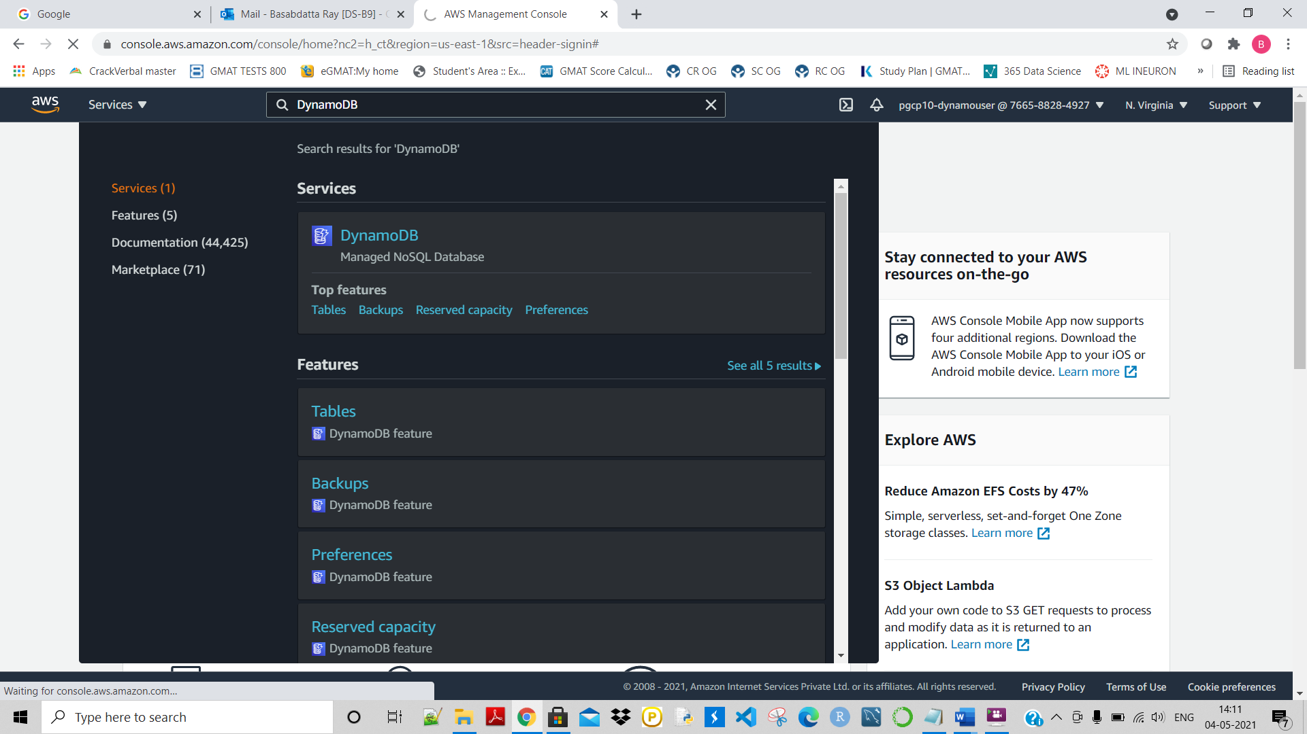

Click on ‘create table’

Here Partition key is given as ‘userid’ and sort key is ‘filmname’ :

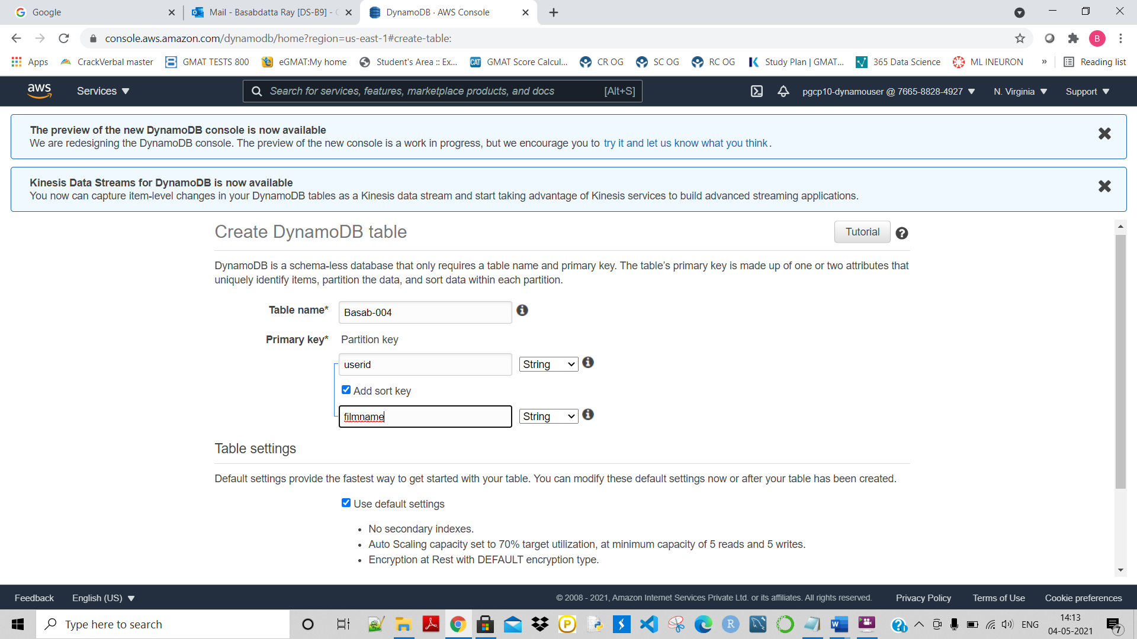

Now give the above details and click on create.

Here we can see that the Table named ‘Basab-004’ has been created successfully:

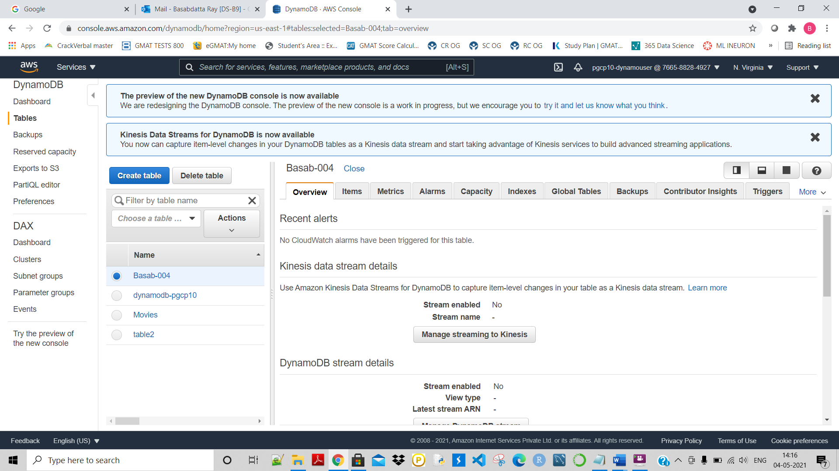

Now let’s create some items/records inside this table:

Click on ‘create item’

And then give the data here as shown. And click on ‘SAVE’:

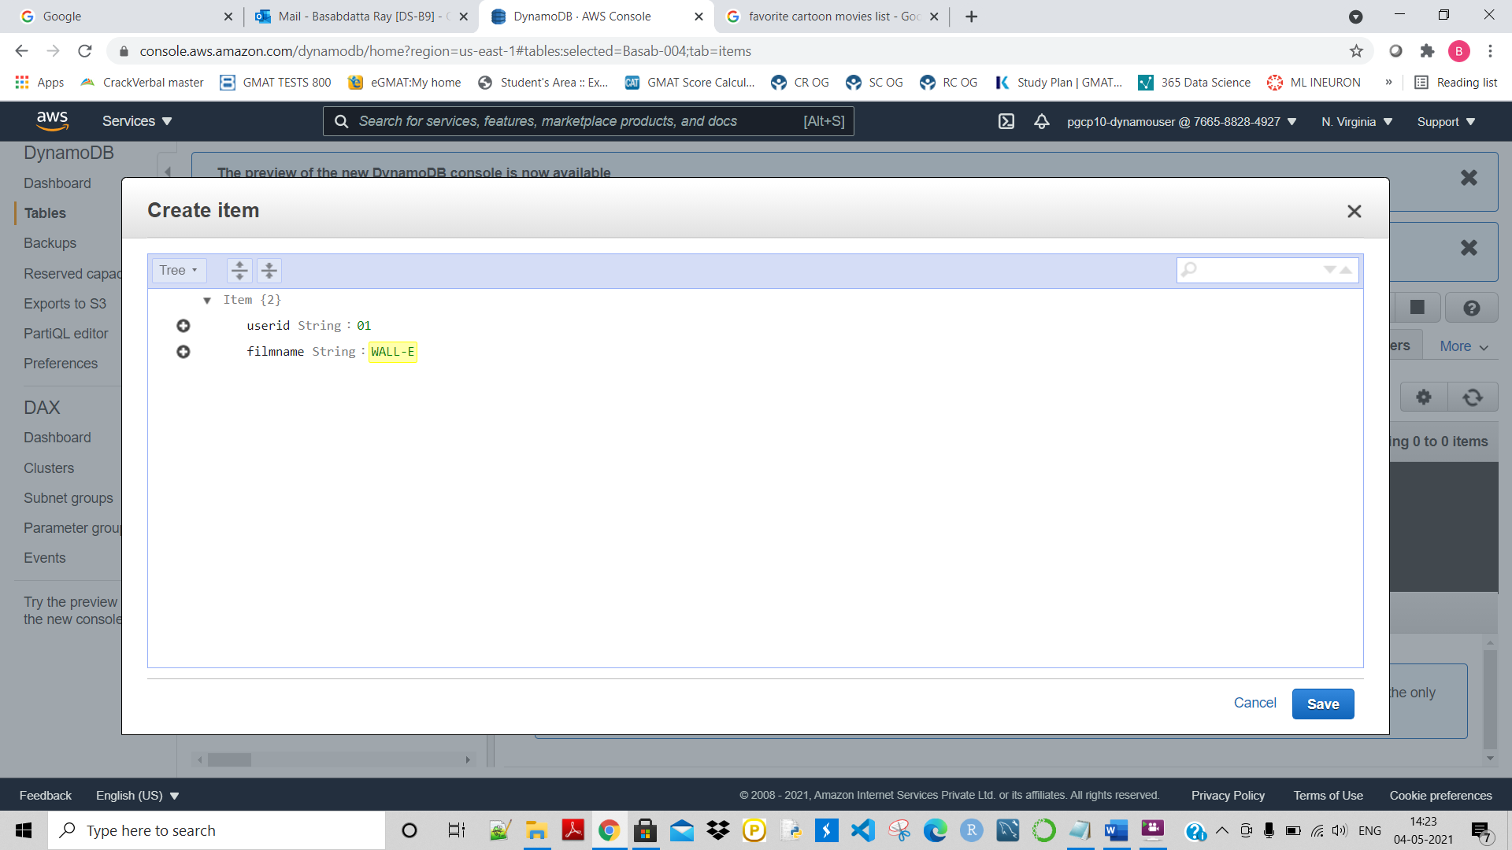

Similarly create some few more records and save those:

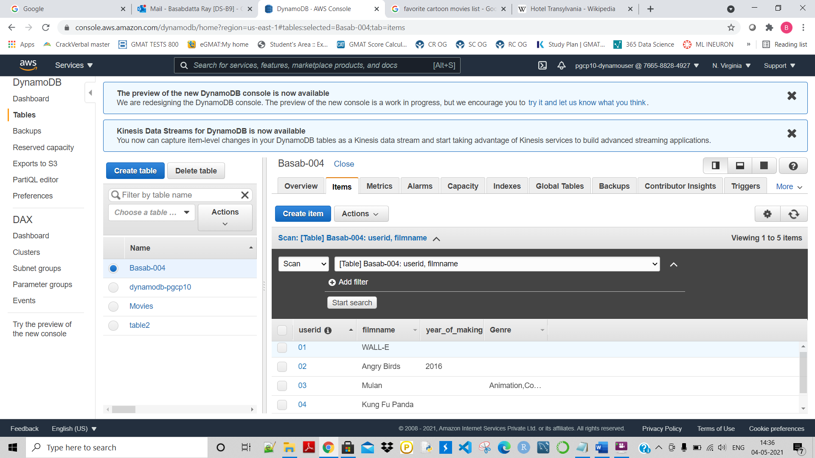

So, using the UI I have created the Table named, ‘Basab-004’:

